Exploring GNUSimu8085 Tools and Instruction Set

Please find the value to be placed instead of placeholder <find> in the program attached (Refer Q1.png) such the you get the output as shown (Refer Q1_Output.png)

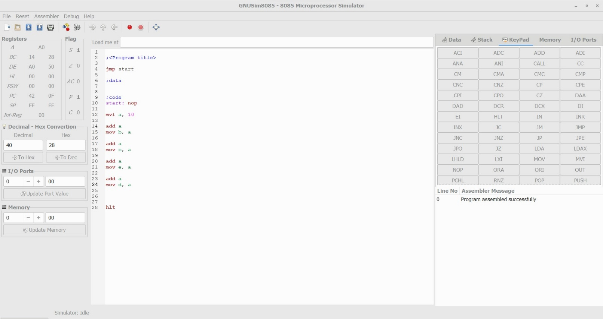

Explanation:

The value 10 is loaded to accumulator A.

Then 10 is added to accumulator.

The result 20 is copied to the register B.

Then 20 is added to accumulator.

The result 40 is copied to the register C.

Then 40 is added to accumulator.

The result 80 is copied to the register E.

Then 80 is added to accumulator.

The result 160 is copied to the register D.

Please write down the difference between the below Instructions

* ADD: - The content of operand are added to the content of the accumulator and the result is stored in Accumulator
* ADC: - addition with carry
* ADI: - Add immediate means add an immediate value withe the content of accumulator and it is stored in accumulator.
* ACI: - Add immediate to accumulator with carry.
* SUB: - Subtract the content of a register or a memory location form the content of accumulator and the result is stored in the accumulator.
* SBB: - Subtract with borrow.
* SUI: - Subtract immediate from accumulator. this instruction subract the immediate data from the content of accumulator and the result is store in accumulator.
* SBI: - Subtract immediate from the content of the accumulator and the result is stored in accumulator.
* JMP: - (unconditionally jump) The program sequence is transferred to the memory location specified by the16-bit address given in the operand.
* JZ: - (conditional jump) The program sequence is transferred to a particular level or a 16-bit address if Z=1 (or zero flag is 0)
* JNZ: - (conditional jump) The program sequence is transferred to a particular level or a 16-bit address if Z=0 (or zero flag is 0)
* MOV:- This instruction copies the contents of the source register into the destination register without any alteration.
* MVI:- The 8-bit data is stored in the destination register or memory.